33 - Smash Mouth – Can’t Get Enough
UNTRANSPOSE previous YAM:Organ0 & 1

[Intro] 2 bars guitar lick
4 bars organ chords

[Verse]
F# B 8x (second 4 with organ)

[Chorus]
C# | d#m | C# | G# a#m | B | C#
2 bars organ chords

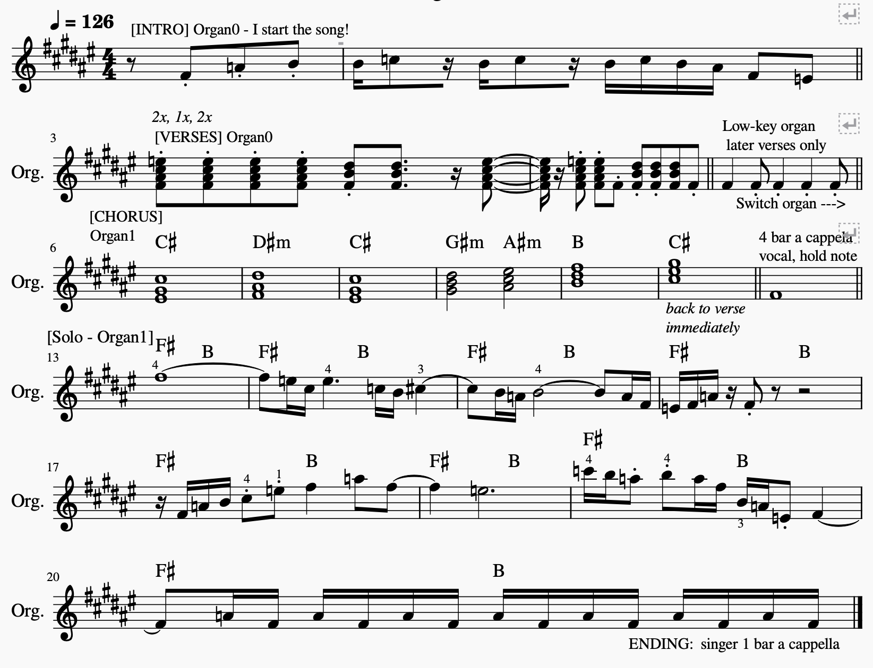
2 verses + chorus then solo on Organ1

